CHAPTER #

CHAPTER TITLE IN ALL CAPITALS
Topics covered in this chapter:
- Bullet list of topics
- Another topic
- Notice how it is indented deeply
- And surrounded by a box
The first paragraph has vertical first line indentation to give it some space below the topics covered.
You should have one or more paragraphs of introduction for each chapter. It should introduce what your goal is, what you're trying to accomplish, and why you want to do it. Don't get into the how yet.
Make sure that you don't have any blocks on the first page if you can help it. Section headings, code listings, console output, notes, tables and images can wait to
be shown on the second page.
The first page has no header or footer.
Line spacing is proportional 120%.

Section Headings
Each chapter is divided into sections. The Chapter title is an H1, the Section heading is an H2

Sub Sections
Sub sections are H3, but are not in the table of contents. Or should they be?
Eventually all Chapters will be merged together, but keep them in separate files for editing.

Console Output
Console output is in a shaded box with a monospaced font with decent space around the borders.
rm -rf /home/aaron
Multiple line console output looks like this:
rm -rf /home/aaron
touch /home/aaron
ls /home/aaron
I thought about adding a shell prompt to console output, but decided not to do it to make cut and paste easier. It might make sense to include it when you should a listing and it's output
$ sudo ls -alp /root
[sudo] password for aaron:
total 92
drwx------ 11 root root 4096 Feb 12 14:18 ./
drwxr-xr-x 28 root root 4096 Jan 14 11:34 ../
The above console output is broken over two pages. Try to avoid this if possible.Inline commands like sudo appear like this to describe something not expected.
Ideally they should only be at the end of the line like this: sudo.

Code Listings
This is a code listing:
listing 1.1
int main() {
println(“hello, world”);

for (int i=0; i<10; i++) {
call(i+1);
if (i > 5) {
call(i+10);
}
}
}
Notice that it uses 2 spaces for indentation, not tabs. Don't forget to number the listing appropriately.

Lists
Lists are single spaced, and indented.

Bulleted Lists
- Item 1
- Item 2
- Item 3
Bulleted lists use diamond bullets (look into getting gem shaped ones.)

Numbered Lists
- First item
- Second item
  - Don't use nested lists.
- Third item

Use hard page breaks sparingling, but use them when it makes sense for grouping.

Misc

Notes
Note: This is a note. It has a dotted box around it and is indented left and right. It has generous spacing above and below. It is also italicized
If you want multiple lines in a note, you need to CTRL+ENTER
or else it will look like this.

URLs
URLs are in an easy to read, monospaced font. They are working links and are underlined and colored blue. They should usually be on a line by themselves.
http://example.com

Footnotes
Add a footnote like this.

Footer
The footer contains the book & chapter titles and page number. E-Books should not distinguish between right and left, but Print should

Margins
The page margins are 0.79” all around (The LibreOffice default.) Paragraphs (and most sections) have a 0.10” margin above and below. Headings have various spacing (TODO: detail heading margins)

Tables
Table Heading | Table Heading 2
Table content | Table Content
Multiple lines in a table cell look like this.
This is another line in a table cell.

Images
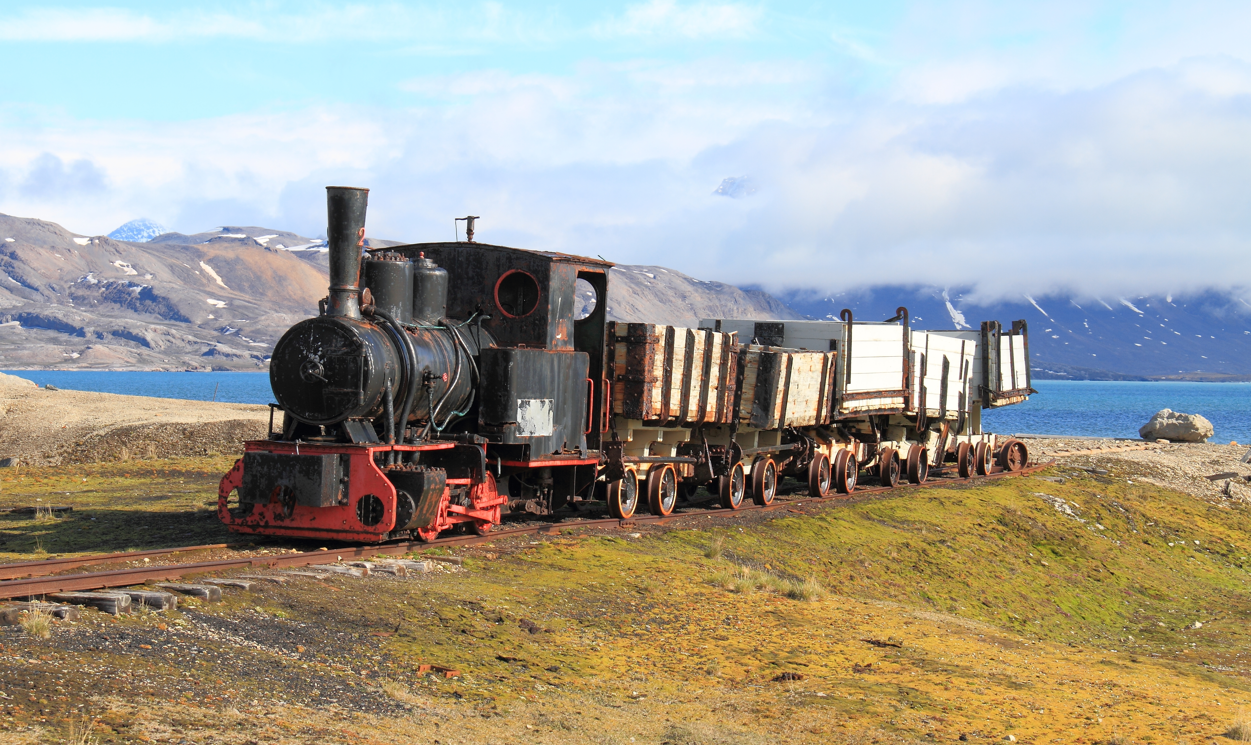
Images should have a centered caption

Ebook vs Print
For print only:
- Chapters should always start on the right hand page
- Page numbering should alternate left/right on print
- Inside margins should be 1.25”

This is the content of the footnote..

